Carrollton Texas Home Storage Center

Location:
1100 West Jackson Road, Carrollton, Texas 75006
Phone: 972-242-8595
Hours of operation:
Tuesday 3:00 p.m.-7:00 p.m.
Saturday from 10:00 AM-2:00 PM.

The Carrollton Home Storage Center is a great resource for food items for home storage. Most of the products they sell come already packaged for long term storage. They also have some short-term storage products (see order form link below for details). An order form with up-to-date prices can be found online at: https://providentliving.churchofjesuschrist.org/food-storage/home-storage-center-locations-map?lang=eng. Scroll down to download a PDF of the current order form. There is also an option to get the form in Spanish. The Home Storage Center in Carrollton does not always have every item in stock, so calling ahead would be advisable. To find out about shortages/and or closings, you should also check out the Carrollton Home Storage Face Book page at: https://www.facebook.com/profile.php?id=100063942016765

How to Decipher the Code on the # 10 Can or Pouch
You can easily tell when the product you purchased from The Church of Jesus Christ of Latter-day Saints was canned. In the stamp on the top of the #10 can, as you read it from left to right, you can ignore everything until you pass the three letters near the center (in this case, DFP). The three numbers to the right of those three letters indicate the day of the year it was canned (in this case the 87th day). The next two numbers tell the year it was canned. This can of food was canned March 28, 2018. The last four numbers indicate the time of day it was canned and can also be ignored.
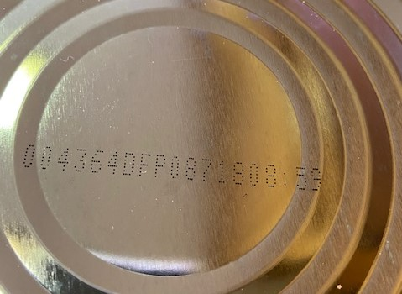
The same system of identification can be used on the pouches such as this pouch of powdered milk in the picture below. Look for this stamp on either the front or back of the pouch. Ignore everything up to and including the three letters in the middle (on this pouch DDP).
The pouch pictured was packaged on the 263rd day (September, 9th) of 2016.

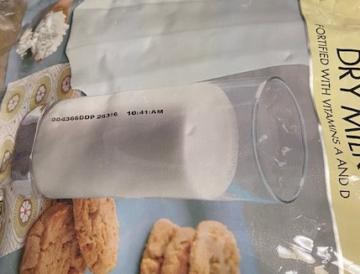
To make things easier on yourself, you could use a permanent marker to mark the date on either the can or the box holding the case of product so you don’t have to do any calculations. You can also just ignore everything except the year and you will be close enough.

The order form which you can download gives a lot of information about each product available such as the weight, how it is packaged (#10 can, pouch, or bag), the price, and the expected shelf life. The shelf life is dependent on it being stored properly in a dry place that is below 75° F.

