**What is Radon?**

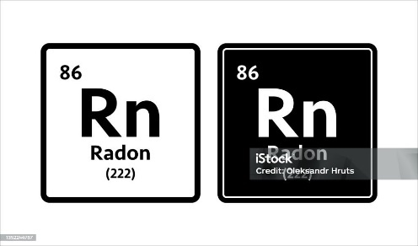

1. **Origin**: Radon is produced from the natural breakdown of uranium in soil, rock, and water. As uranium decays, it releases radon gas, which then moves through the soil and can seep into buildings.
2. **Properties**: Radon is a noble gas, meaning it is chemically inert and does not react with other elements. Its lack of color, taste, and smell makes it difficult to detect without specialized equipment.

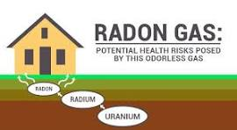

**Why is Radon Dangerous?**

1. **Health Risks**: Radon is a known carcinogen. Prolonged exposure to high levels of radon can significantly increase the risk of lung cancer. In fact, radon exposure is the second leading cause of lung cancer after smoking. When radon gas is inhaled, radioactive particles can become trapped in the lungs, leading to potential damage over time.
2. **How It Affects You**: The risk of developing lung cancer from radon is compounded if you smoke or have been exposed to other carcinogens. However, even non-smokers are at risk if they are exposed to high levels of radon over many years.

**How Does Radon Get Into Your Home?**

1. **Entry Points**: Radon can enter a home through cracks in the foundation, gaps around pipes, and spaces in floors and walls. It can also accumulate in water from wells, although this is less common.
2. **Building Factors**: Homes built on soil with high levels of uranium or those with poor ventilation are more likely to have elevated radon levels. Radon levels can vary significantly from one house to another, even in the same neighborhood.

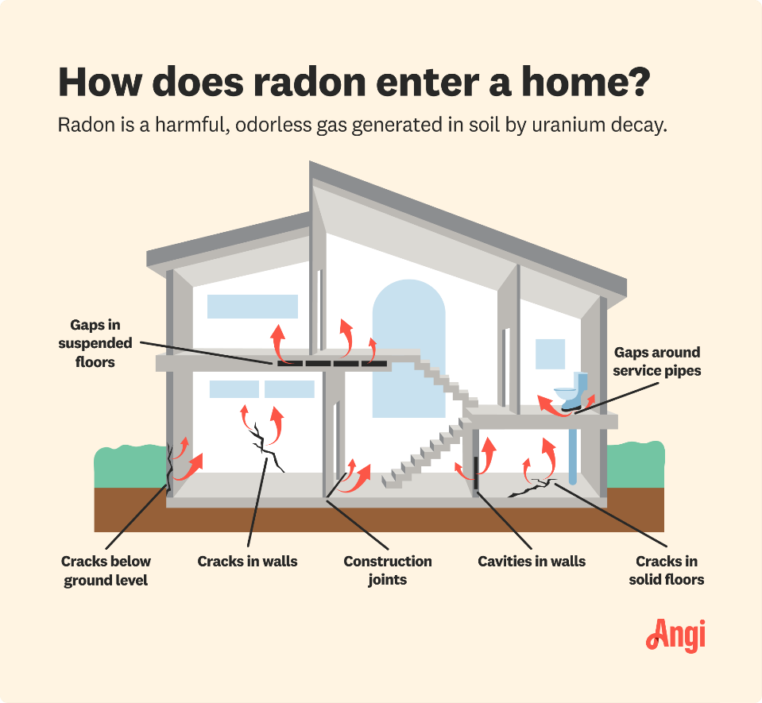

**Testing and Mitigation**

1. **Testing**: The only way to know if your home has high radon levels is to test for it. Radon test kits are available for purchase at hardware stores or online, or you can hire a professional to conduct the test. Testing is relatively inexpensive and straightforward.

 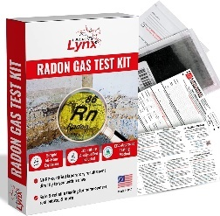 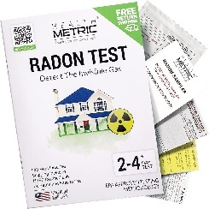

1. **Mitigation**: If high radon levels are detected, there are effective mitigation methods. The most common approach is to install a radon mitigation system, which typically includes a vent pipe system and fan that pulls radon from beneath the house and vents it outside. This can significantly reduce radon levels and improve air quality.
2. **Prevention**: For new constructions, radon-resistant features can be included in the design and construction phases to minimize radon entry and accumulation.

Radon is a serious environmental health risk, but it is manageable with proper testing and mitigation. If you’re concerned about radon levels in your home, testing is the first step. With the right measures, you can reduce your exposure and protect your health.

**What is Carbon Monoxide?**

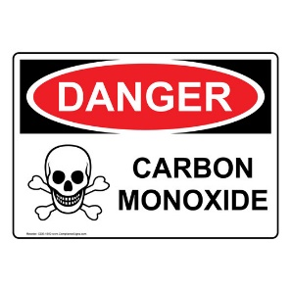

Carbon monoxide (CO) is a colorless, odorless gas that can be extremely dangerous. It’s produced by incomplete combustion of carbon-containing fuels, such as gas, wood, coal, and oil. This can occur in various settings, including residential, industrial, and automotive environments. Here’s a closer look at its causes and the dangers it poses:

**Causes of Carbon Monoxide**

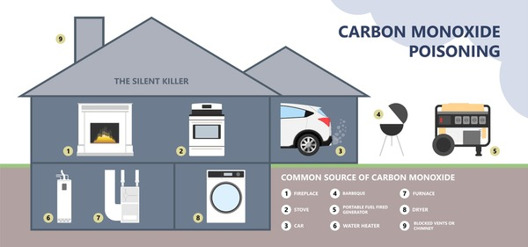

1. **Faulty Appliances:** Common household appliances like gas stoves, heaters, and water heaters can produce CO if they’re not functioning correctly or are poorly maintained. For instance, a blocked flue or chimney can prevent the proper venting of CO.
2. **Vehicle Exhaust:** Running a vehicle in an enclosed or poorly ventilated space, such as a garage, can lead to dangerous CO buildup. Even if the garage door is open, CO levels can still reach harmful levels.
3. **Burning Fossil Fuels:** Incomplete combustion of fuels such as coal, wood, or oil in stoves, fireplaces, and furnaces can release CO into the air.
4. **Generators and Portable Heaters:** Using generators or portable heaters indoors or in enclosed spaces can also lead to CO accumulation.

**Dangers of Carbon Monoxide**

1. **Health Risks:** CO interferes with the body’s ability to transport oxygen. When inhaled, it binds with hemoglobin in the blood more effectively than oxygen, leading to reduced oxygen delivery to vital organs and tissues. This can cause symptoms ranging from mild (headache, dizziness, nausea) to severe (confusion, loss of consciousness, and even death).
2. **Silent Threat:** Because CO is both colorless and odorless, it’s difficult to detect without a carbon monoxide detector. This makes it particularly dangerous, as people can be exposed to high levels without realizing it.
3. **Chronic Exposure:** Long-term or low-level exposure to CO can lead to persistent health issues, including respiratory problems and cognitive impairments. This is especially dangerous for individuals with pre-existing health conditions or vulnerable populations like the elderly and children.
4. **Increased Risk in Winter:** CO poisoning incidents often rise in winter due to increased use of heating appliances and less ventilation. Additionally, snow blocking vents and chimneys can exacerbate the risk.

**Prevention and Safety Measures**

* **Install CO Detectors:** Place carbon monoxide detectors in key areas of your home, such as near sleeping areas and on every level of the house.

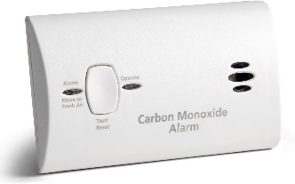 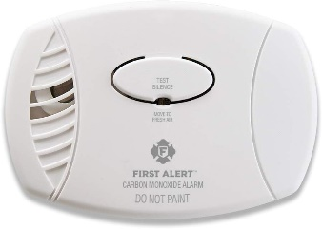

* **Regular Maintenance:** Ensure that all fuel-burning appliances are regularly serviced by qualified professionals and that vents and chimneys are kept clear.
* **Safe Practices:** Never use generators, grills, or gas-powered tools indoors or in enclosed spaces. Make sure your vehicle is turned off before entering a garage.
* **Know the Symptoms:** Be aware of the symptoms of CO poisoning and seek fresh air and medical attention immediately if they occur.

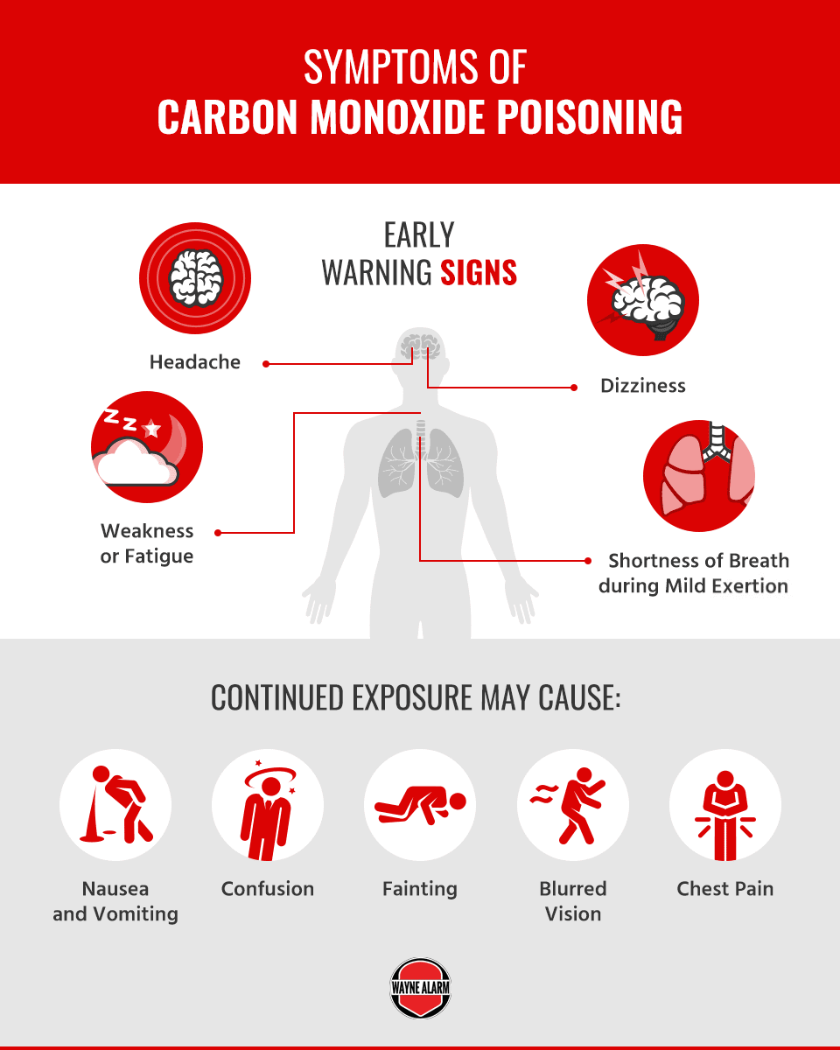

Understanding and mitigating the risks of carbon monoxide is crucial for safety and health. Regular maintenance, proper usage of appliances, and awareness of the symptoms can significantly reduce the dangers associated with this silent but deadly gas.

**Fire Safety Practices**

1. **Install Smoke Alarms:**
   * **Placement:** Install smoke alarms in every bedroom, outside each sleeping area, and on every level of your home.
   * **Maintenance:** Test alarms monthly and change the batteries at least once a year. Replace smoke alarms every 10 years.

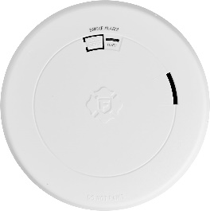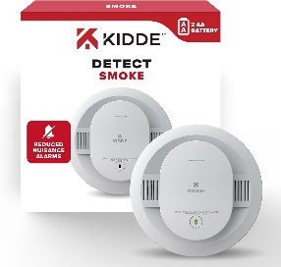

1. **Develop a Fire Escape Plan:**
   * **Create a Plan:** Map out two ways to exit every room in your home. Ensure that all family members are familiar with the plan.

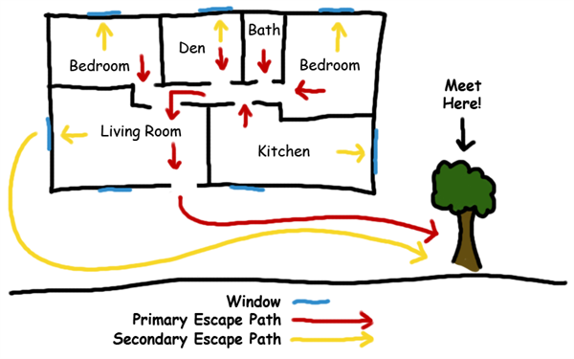

* + **Practice Regularly:** Conduct fire drills at least twice a year so everyone knows what to do in case of an emergency.

1. **Use Fire Extinguishers:**
   * **Types:** Have a fire extinguisher in key locations, such as the kitchen and near potential fire hazards. Know how to use it by following the PASS (Pull, Aim, Squeeze, Sweep) method.

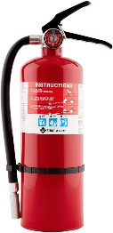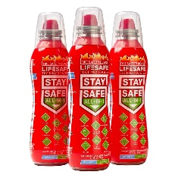 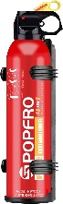 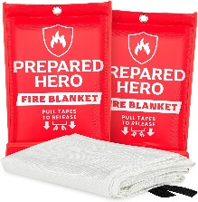

* + **Maintenance:** Check extinguishers monthly to ensure they are fully charged and operational. Replace or service them according to the manufacturer’s instructions.

1. **Keep Safe Distances:**
   * **Flammable Materials:** Store flammable liquids like gasoline or propane away from heat sources and out of reach of children.
   * **Space Heaters:** Maintain a safe distance between space heaters and anything that can burn, such as furniture, paper, and clothing.
2. **Safe Cooking Practices:**
   * **Stay Attentive:** Never leave cooking food unattended. Use a timer to remind you if you’re distracted.
   * **Grease Fires:** If a grease fire starts, cover it with a lid and turn off the heat. Never use water to extinguish a grease fire.
3. **Electrical Safety:**
   * **Inspection:** Regularly inspect cords and plugs for damage. Avoid overloading outlets and use extension cords safely.
   * **Qualified Repairs:** Have a qualified electrician handle electrical issues and install wiring safely.

**Fire Prevention Measures**

1. **Proper Disposal:**
   * **Ashes and Embers:** Allow ashes to cool completely before disposing of them. Place them in a metal container with a tight-fitting lid and keep it outside away from combustible materials.
2. **Maintain Heating Systems:**
   * **Professional Service:** Have heating systems, including furnaces and fireplaces, inspected and cleaned annually by a professional.
   * **Fireplace Safety:** Use a fireplace screen to contain sparks and embers. Ensure the chimney is regularly cleaned.
3. **Secure Matches and Lighters:**
   * **Storage:** Keep matches and lighters out of reach of children, ideally in a locked cabinet or drawer.
4. **Fire-Resistant Materials:**
   * **Construction:** Use fire-resistant materials for roofing and siding if building or renovating. Install fire-resistant doors and windows where possible.
5. **Outdoor Safety:**
   * **Burning:** Follow local regulations regarding outdoor burning. Keep a water source or fire extinguisher nearby when burning yard debris.
   * **Landscaping:** Maintain a defensible space around your home by clearing flammable vegetation and keeping your lawn well-watered.
6. **Education and Awareness:**
   * **Training:** Educate family members about fire safety and prevention. Teach children about the dangers of fire and the importance of following safety rules.

By following these fire safety and prevention practices, you can significantly reduce the risk of fire and ensure a safer environment for yourself and those around you. Being proactive and prepared can make a crucial difference in effectively managing and preventing fire-related emergencies.

Top of Form

Bottom of Form