**Indoor Hydroponic System for Beginners (What You Need and Why)**

If you aren’t familiar with hydroponics, then this article is a **Hydroponics for Beginners** article and is (hopefully) help you to start you growing indoors. It might seem intimidating to set up your own indoor hydroponic grow system. You might think you’ll need a lot of special equipment, that it will be expensive to set up, or the process will be too complicated. This is an article for beginners and will help you learn about hydroponics. It will help you to understand that you don’t need to be an expert to grow your own plants hydroponically indoors and that you can put together your own system quite cheaply and without much fuss.

With a bit of research, you can find the **best indoor hydroponic system for vegetables** that works for you. You can also build your own system with a few basic supplies. Your indoor hydroponic system can be as big or small as you’d like. It can be as simple or high tech, cheap or expensive as you want it to be.

**What is Hydroponics for Beginners?**

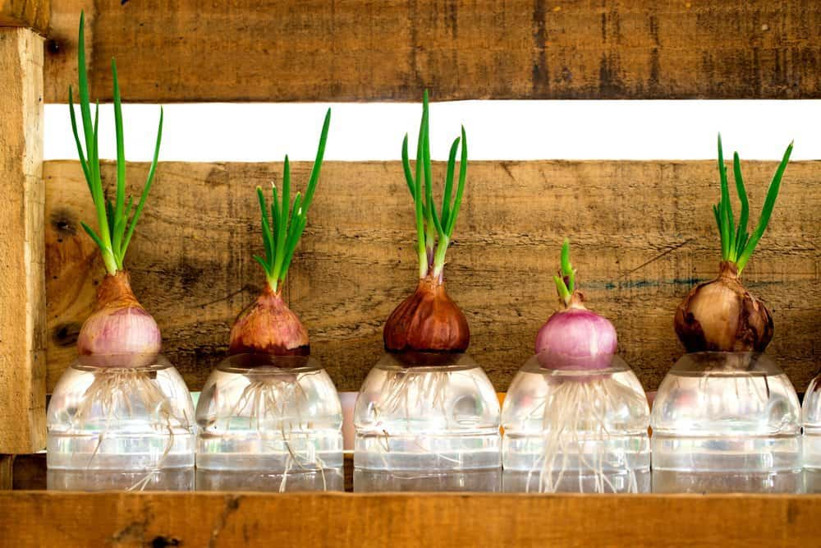

Hydroponic growing is not just for the advanced gardener or for commercial farms. In fact, hydroponics for beginners has become an extremely popular way to grow herbs, vegetables or other greenery in your home, year-round. Anyone can grow their plants hydroponically, even if they don’t yet fully understand what that means. It can be very simple or as sophisticated as you want.

“Hydroponics” refers to any method of growing plants without soil, using simply mineral nutrient solutions and water. Plants can grow with their roots directly submerged in mineral solution, or you can use perlite, gravel, or other medium.

**Hydroponics for Beginners - Why Grow Hydroponically?**

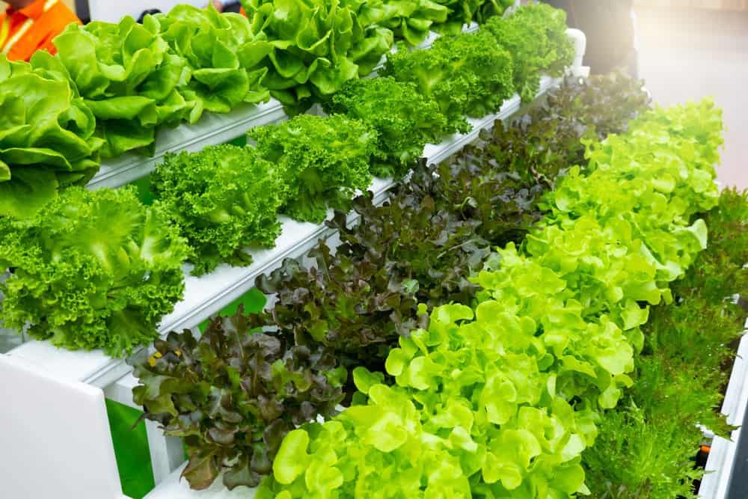

There are many reasons to grow your plants hydroponically, but the most common reasons involve faster growth and maximum yield. In a properly functioning hydroponic system, your plants should get the perfect amount of nutrients, water, and sunlight.

When plants receive their basic needs without expending energy extracting nutrients from the soil, they can concentrate on simply growing. Hydroponics is the most efficient way to grow your plants.

Another excellent reason to grow your plants hydroponically is the lack of soil. Anyone with an indoor garden knows how messy it can be. Trying to plant, repot, and fertilize your plants on your kitchen counter or table can create chaos. Sure, hydroponic gardening might involve some spilled water or stray clippings. But these messes are much easier to clean up than dark soil getting ground into your carpet.

**Hydroponics for Beginners - The Benefits**

Indoor gardeners will appreciate all the space they can save by growing their plants spaced much more closely together. Roots won’t need to spread out deep into the soil, looking for nutrients. And you won’t need to take up space with large pots or drainage trays. Of course, you may enjoy the look of your plants spread around the house in their lovely pots. But if you’re short on space and want to grow a crop of veggies, then what? You’ll appreciate the space you save with a hydroponic system.

Weeds are eliminated in a hydroponic system and pests are almost nonexistent. Pests might still find their way to your plants, but they’ll be less of an issue compared to soil gardening.

**Hydroponics for Beginners - Choosing a Hydroponic System**

There are six main types of hydroponic systems to choose from. All these systems use water and nutrient solutions, and they do not require soil. The basic elements are the same, but each system delivers these needs just a little differently.

**Water Culture**

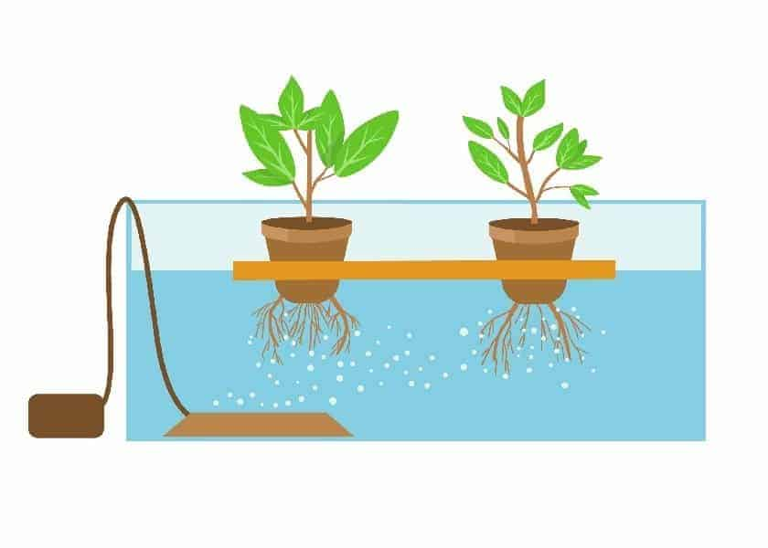

Probably the simplest and most inexpensive systems is Water Culture. The plant is placed in a basket above a reservoir filled with nutrient solution. From there, the roots hang down, submerged in the nutritive water solution. Because the roots are constantly submerged, they’ll require aeration to prevent suffocation. Aeration can be provided with an **air pump**, **air stones**, or from a falling water system that creates air bubbles.

**Nutrient Film Technique (NFT)**

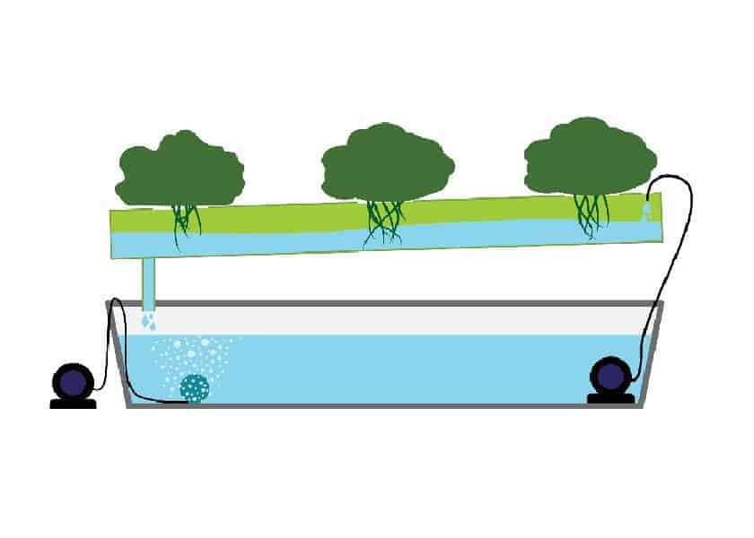

The Nutrient Film Technique is another simple setup that’s a popular choice for home gardens, but a little more expensive than the Water Culture System. The system involves a shallow stream of nutrient solution which flows through a downward sloped channel. The roots of the plants hang into this stream and absorb nutrients from the steady flow. This system is excellent for small, fast growing plants like lettuce, herbs, and baby greens.

**Aeroponic**

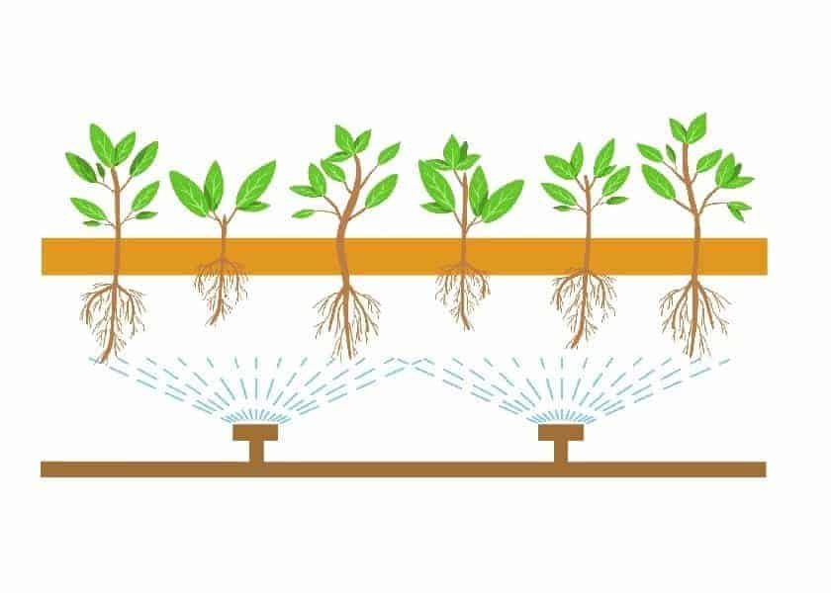

Aeroponic systems create an environment for the roots that provides as much oxygen as possible. The roots hang in midair within a growing chamber, without growing medium, so the entire root system can be exposed. Within the growing chamber, the roots are sprayed at regular intervals with **aeroponic misters**. The misters provide the plant with a nutrient solution and prevents the roots from drying out. One drawback is that this system takes up more space and is a little more complicated and expensive to set up.

These systems feature a hydroponic system that allows plants to grow without soil, using water and nutrients to nourish the roots directly. This hydroponic system eliminates the need for messy soil and allows for faster growth and higher yields. The designs of these type models are sleek and modern, making them suitable for any room in your home. They come with LED grow lights that provide the perfect spectrum and intensity of light for optimal plant growth, allowing you to grow a variety of plants, including herbs, vegetables, flowers, and more, all year round.

**Ebb and Flow**

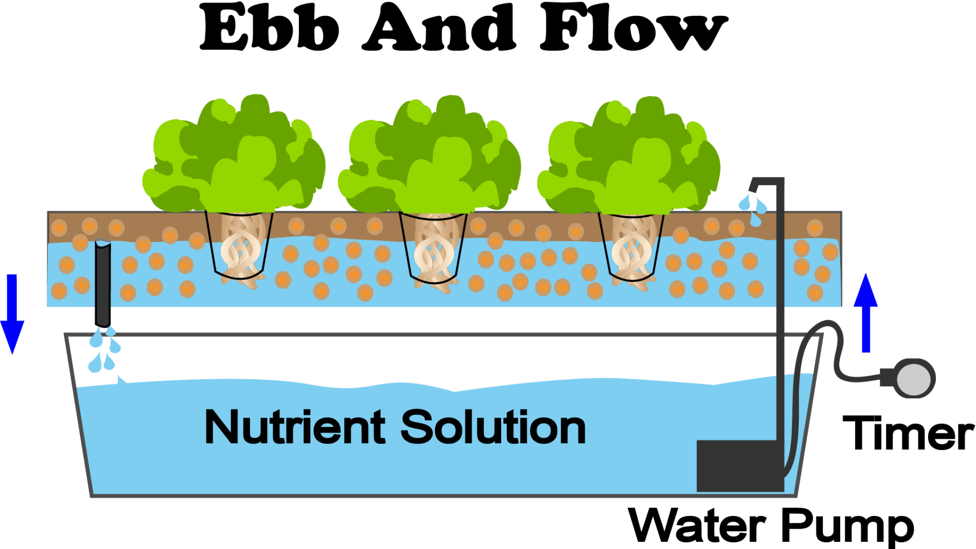

The Ebb and Flow, or Flood and Drain, technique uses a **water pump** on a **timer**. There are many ready-to-use systems you can buy. It floods and then drains the root system with water and nutrients. The water reaches a height where it will soak the roots and the excess water drains through an overflow tube. When the pump shuts off at the designated time, the water drains back down to the reservoir. It stays there until the pump turns on again. This system provides the roots with alternating periods of air and oxygen then water and nutrients.

**Drip**

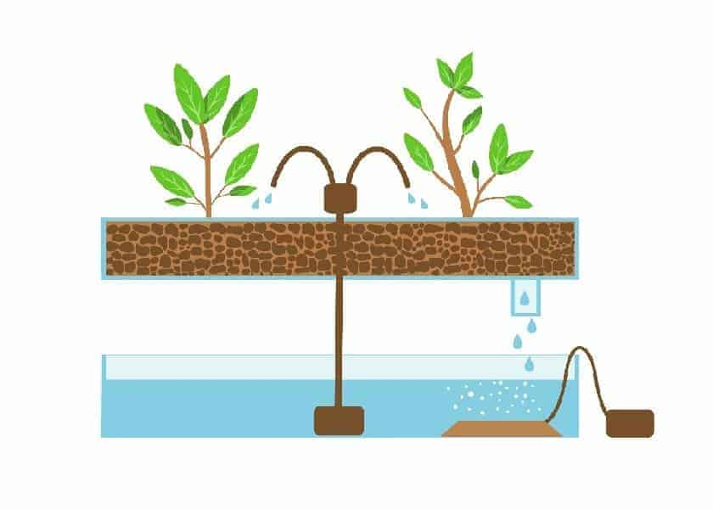

The **drip system** is a fairly straightforward concept and it works exactly as it sounds. The plants’ roots are placed in a growing media such as perlite or gravel. Then, a water and nutrient solution is pumped from a reservoir, through tubes, to drip onto the roots. The growing medium and roots are soaked, then the solution drips back into the container and flows to the reservoir. This system is great for larger plants with larger root systems. It works well, because the growing medium retains some of the moisture and keeps large root systems well hydrated.

**Wicking**

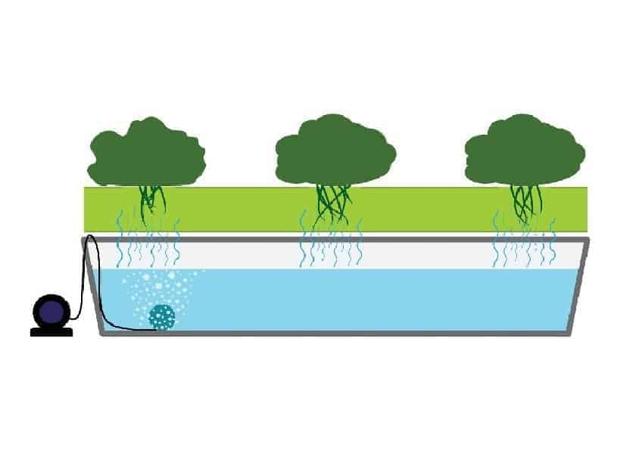

The **wicking system** is very simple and inexpensive. Plants sit within a wicking medium, such as vermiculite or perlite. A wicking rope or strips of felt are used to connect the wicking medium to the solution the medium is directly in the water thus feeding the roots. Using a wicking method, the medium dries out, and more water and nutrient solution is pulled up via the wicking rope. No pumps or moving parts are required with this technique. The wick will simply pull the moisture toward the plant as needed.

**Hydroponics for Beginners - Supplies You'll Need**

Once you’ve decided on the type of system you want to create, you’ll need to get your supplies together. Some of the techniques mentioned use growing medium, some have grow lights included some use pumps, and some use wicking ropes. They all vary a little but you’ll need most of the following supplies to create your perfect indoor hydroponic system.

**Plants**

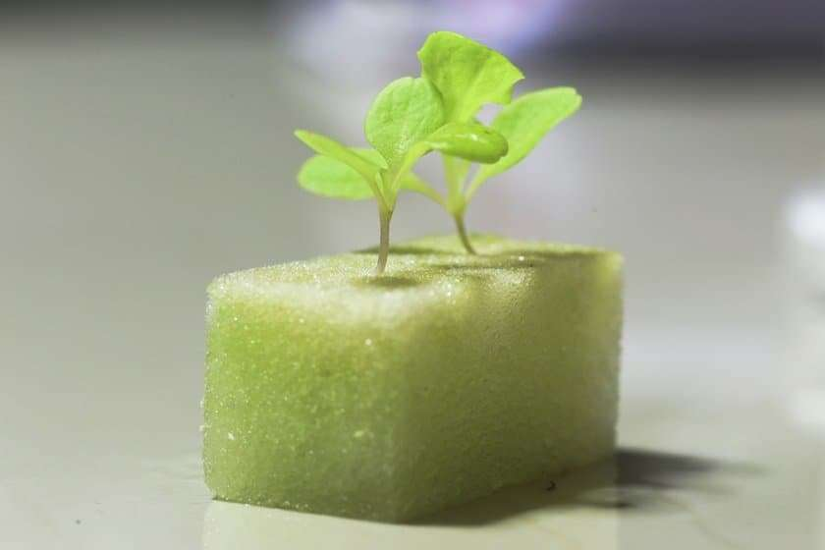 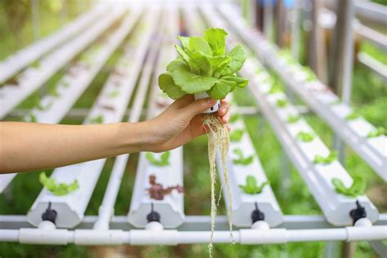 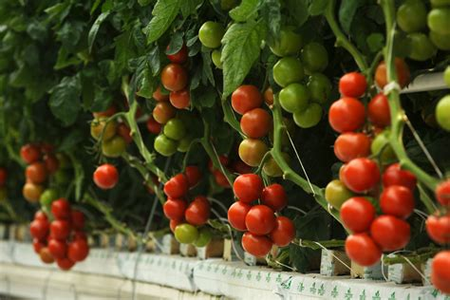

It’s unlikely that you’ll be building a hydroponic system and not putting plants in it. It is important to consider the potential size of the plants you’ll be growing. Make sure there’s room in your system for their roots and a strong enough frame to support your plant’s structure.

If you’re new to hydroponic gardening, it’s best to start with a live plant rather than growing from seeds. However, if you do choose to start with a live plant or seedling, be sure to thoroughly rinse the soil from your plant’s roots. This will avoid contamination of your water and nutrient solution.

**Support Structure**

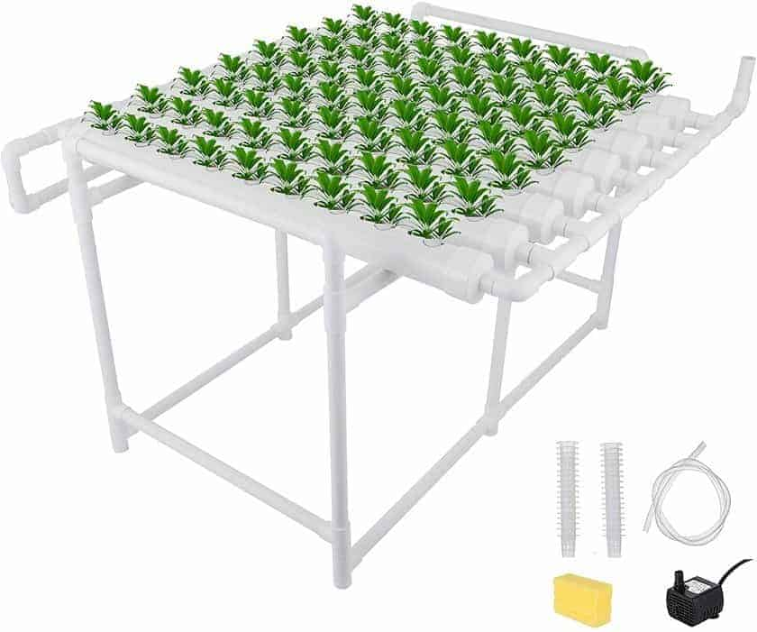 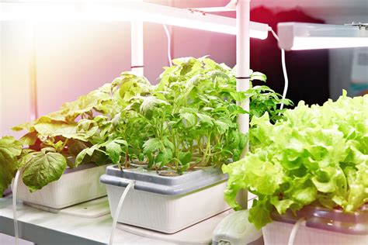

You’ll need some type of support for your plants. This could be a section of wire mesh or a basket that will allow the roots to hang down. Your plants will need a container for the roots to hang into as well. This could be a long piece of **plastic piping** or a big bucket. When using a bucket with a lid, cut holes in the lid to place your mesh or basket in. This creates an enclosure that will prevent moisture from escaping.

**Reservoir**

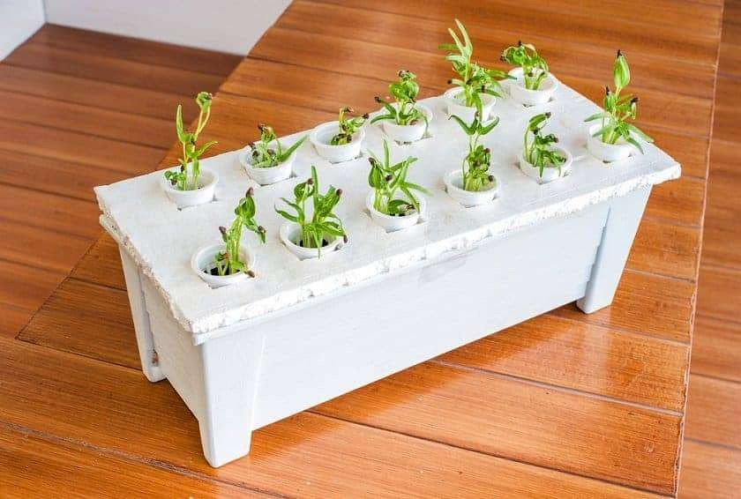

So, we’ve discussed the space where your plant’s roots will be exposed to water and nutrients. You’ll also need a reservoir where the water and nutrient solution is stored. If you’re using the Water Culture technique, the water reservoir and root basin will be the same space. If you buy pre-built systems, then everything will be included.

**Growing Medium**

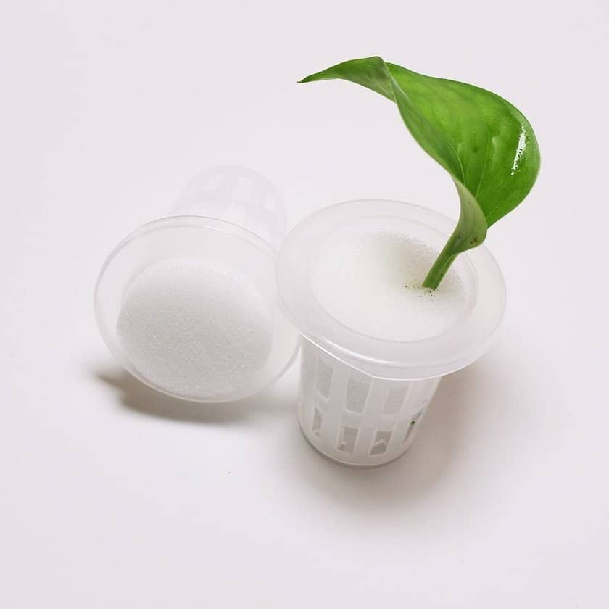

You may or may not require a growing medium, depending on the hydroponic system you choose. Should you need a growing medium, gravel, **perlite**, and **vermiculite** work well. The growing medium is placed around your plant’s roots, within a basket or on top of a fine wire mesh. When starting your plants from seeds, **hydroponic sponges** can also be very handy.

**Water Pumps**

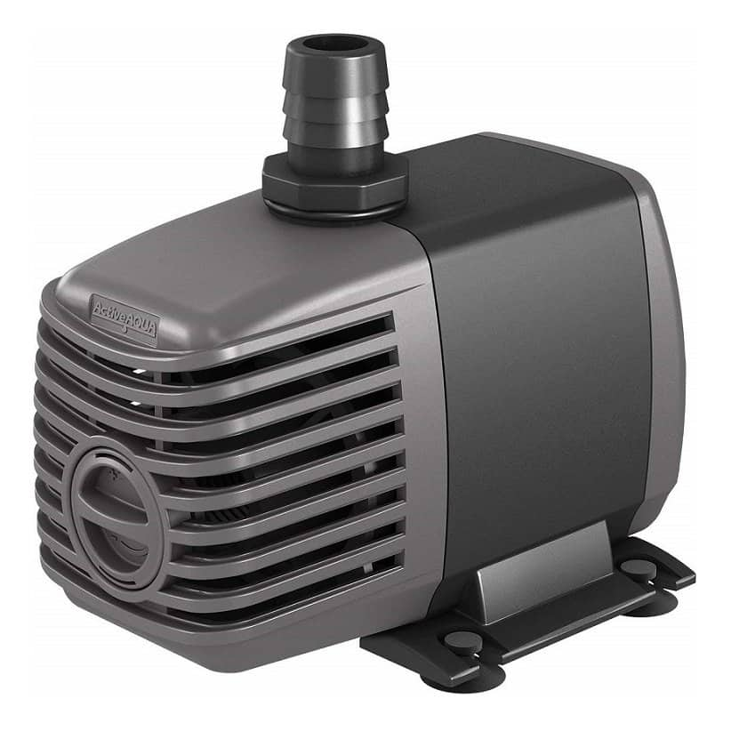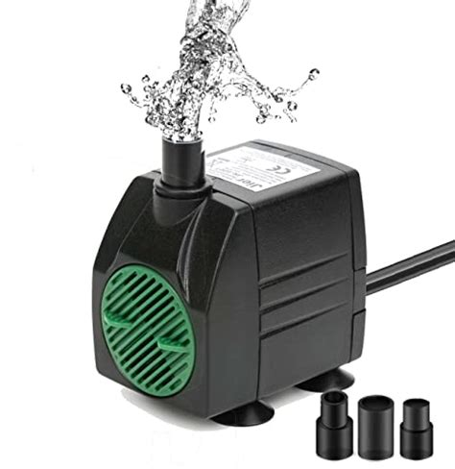 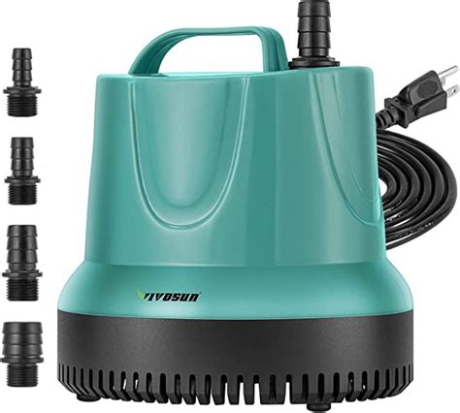

Unless you’re using the wicking system, you’ll likely require a **water pump**. This is the only piece of actual machinery you’ll need. Best of all, simple water pumps can be purchased fairly cheaply. You can also use a water pump with a timer for the ebb and flow system.

**Tubing**

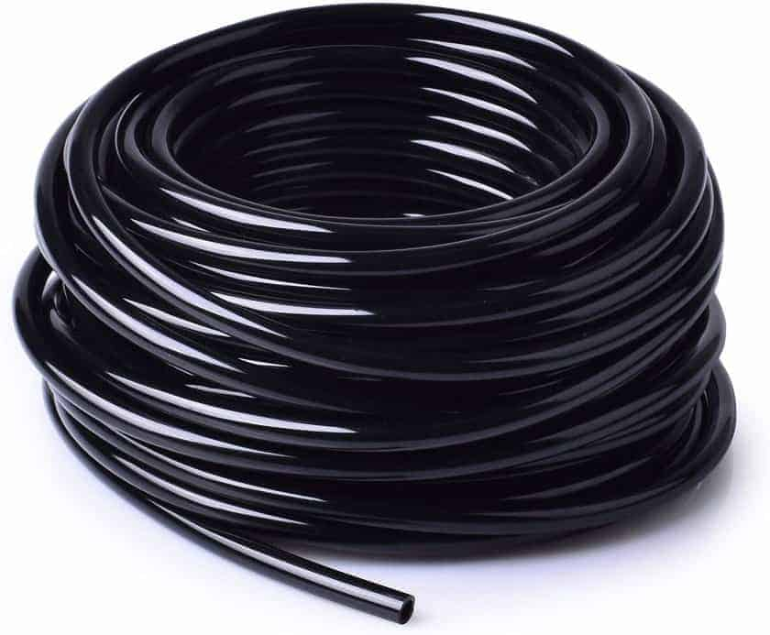

**Tubing** is quite cheap and is incredibly easy to find online or in any home improvement store. You’ll just need something than can transport your water and nutrient solution from your reservoir to your root basin and back again. It’s important to ensure your tubing is the correct diameter to connect with any water pump or mister fittings you’ll be using. Also be sure to look for tubing that won’t kink up and interrupt your water flow.

**Nutrient Solution**

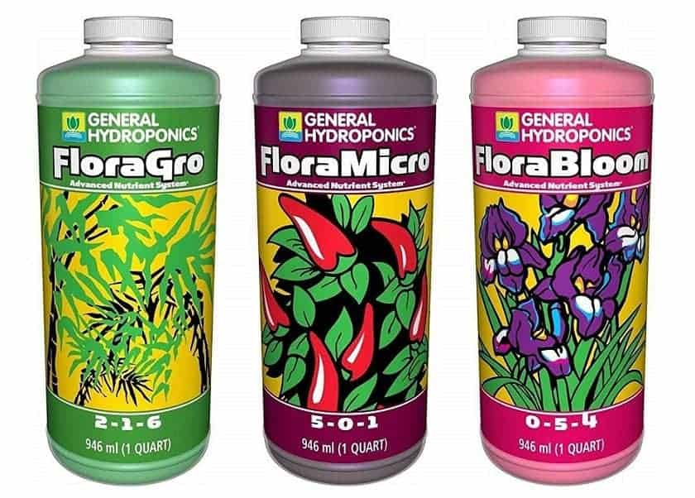 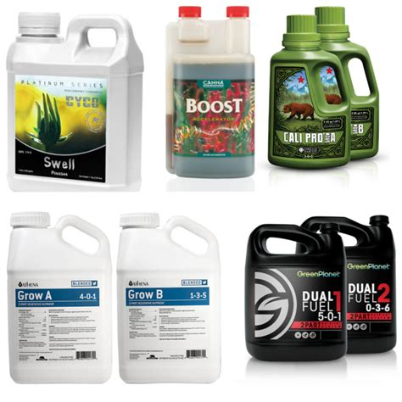 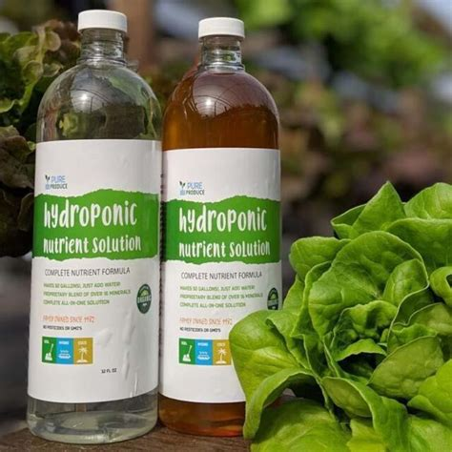

Your **nutrient solution** is one of the most important supplies you’ll purchase and it’s crucial to choose a high quality solution that’s right for the specific types of plants you’re growing. Advanced hydroponic gardeners may even choose to make their own custom nutrient solutions but if you’re looking for a good pre-made brand you can try **General Hydroponics** or Advanced Nutrients.

**Water**

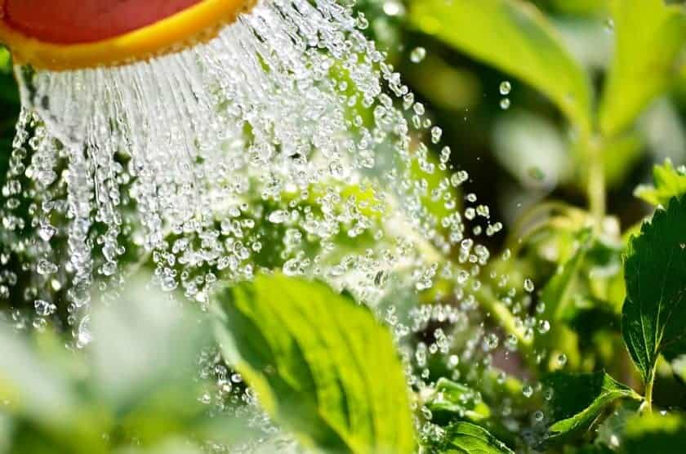

Needing water for your plants seems like a simple and obvious thing, but the quality of your water can play a big part in how well your plants will grow. You could use tap water but for the best results it’s best to go with fresh rainwater or bottled spring water. Tap water may contain unwanted minerals or may have an undesirable pH level.

**pH Control**

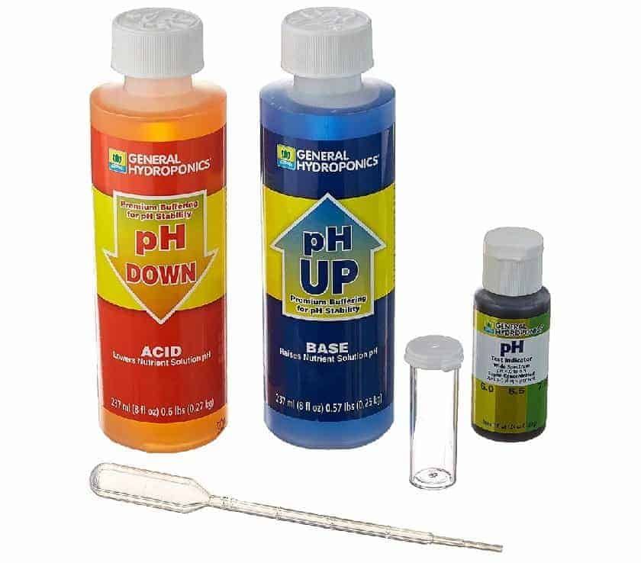

pH is an important factor when it comes to caring for your plants. Especially in a hydroponic system, where your plants are nearly constantly submerged, you’ll want to ensure you stay as close to the range that your plant needs as possible. Some plants prefer different pH levels but a typical zone to shoot for is around 6.0 to 7.0. You can purchase a **pH testing kit** in order to keep an eye on your levels and add **pH-Up or pH-Down** to your water reservoir as needed to maintain the perfect pH. Tap water or bottled water is usually 7.0.

**Grow Lights**

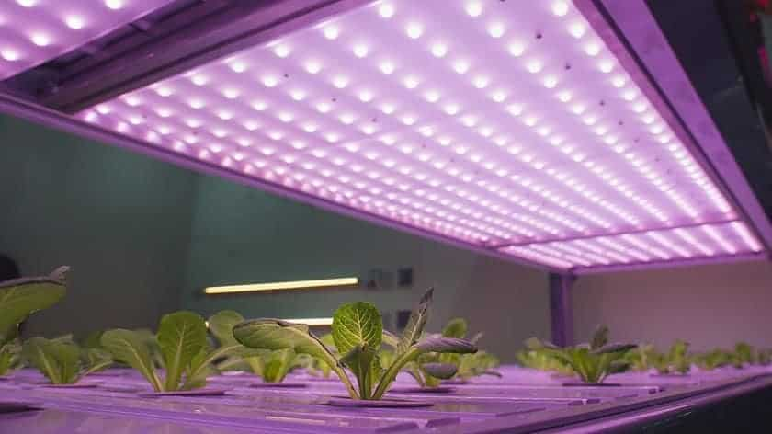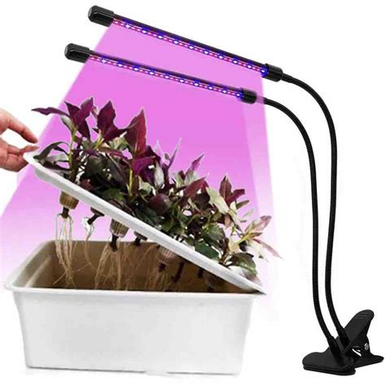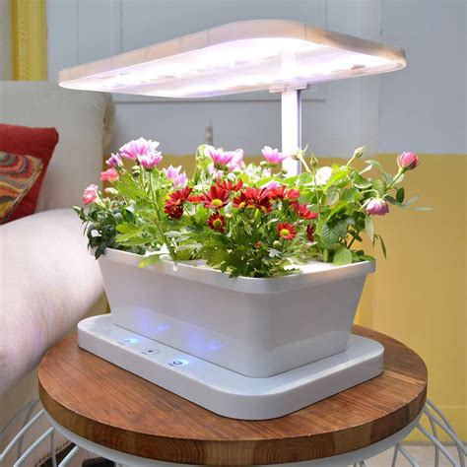

Your plants should have at least 6 hours of sunlight per day so it’s important to position them in a spot that receives ample light. If this can’t be done inside your home, you may want to purchase some **grow lights** in order to give them that added boost of sunlight they’ll need to thrive.

**All Inclusive Hydroponic Kits**

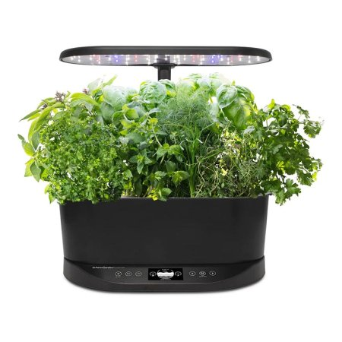 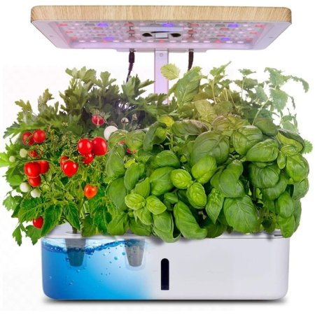 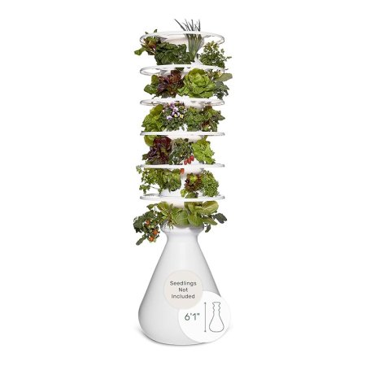 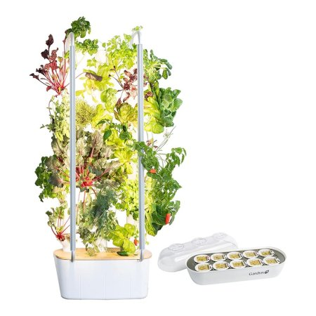

AreoGarden Moistenland Farmstand Gardyn

There are plenty of hydroponic kits like AeroGarden, Moistenland, Farmstand, Gardyn, Rise Gardens among otheres you can purchase that will come all set up for you, or kits that will provide you with all the supplies you need to get started. It’s not too difficult to build your own system but if you want to make it even easier on yourself, look online and see what type might be best for you.

**Hydroponics for Beginners - The Wrap-up**

Creating an indoor hydroponic system for where you can grow veggies, herbs, and other plants is a lot easier than you realize. In fact, hydroponics for beginners is for just about anyone. The basic idea is simply to provide your plant’s roots with water, nutrients, and oxygen in the absence of soil. It can be done using any number of the techniques or systems previously mentioned or you can do some research online and come up with your own hybrid style of hydroponic gardening.

You can easily purchase any of the supplies you need from a gardening center or an online retailer, or you can simply use any buckets, old tubing, or wire mesh that you might find around your house. Think about the different systems and techniques, see what you’ve got lying around, and come up with your own unique indoor hydroponic system.

**\*\*\*\* THERE ARE NO SYSTEMS THAT WE ENDORSE, ONE OVER THE OTHER, BUT THERE ARE SYSTEMS WE HAVE BOUGHT AND USED. YOU NEED TO DETERMINE WHAT IS BEST FOR YOU BASED ON SPACE, COST AND WHAT YOU WANT TO GROW\*\*\*\***

**LINKS THAT CAN HELP**

* **Indoor Gardening Articles****,****Indoor Hydroponics****,****Indoor Plant Care**
* **http://www.homehydrosystems.com/hydroponic-systems/water-culture_systems.html**
* **https://www.bobvila.com/articles/best-hydroponic-system/**
* **https://reviewed.usatoday.com/home-outdoors/best-right-now/best-hydroponic-garden-systems**
* **https://mygardyn.com/**
* **https://aerogarden.com/home/**
* **https://www.lettucegrow.com/store/**
* **https://www.idooworld.com/collections/hydroponics-grow-planter**
* **https://risegardens.com/products/personal-indoor-garden**